
Agency Integrator TECHNOTE
Enhancement Request

March 2023

This TechNote describes the UserVoice Enhancement Request module available within Agency Integrator.

Contents
Introduction 2
Accessing Enhancement Requests 2
Submitting New Enhancement Requests 3
Reviewing Enhancement Requests 5
Discussing Enhancement Requests 7
Voting on Enhancement Requests 8
UserVoice Settings 11

Introduction
UserVoice allows you to submit, review, discuss, and vote on Feature Enhancements Requests. We’ll review each function.

Accessing Enhancement Requests
Once logged into Agency Integrator, hover over Resources on the top menu bar and click Enhancement Request.
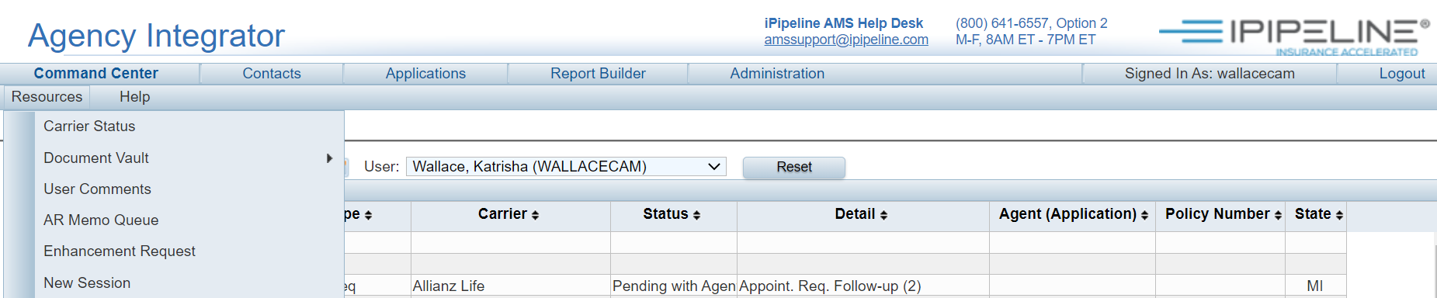
You will be logged into the UserVoice - Agency Integrator Feature Requests tool:
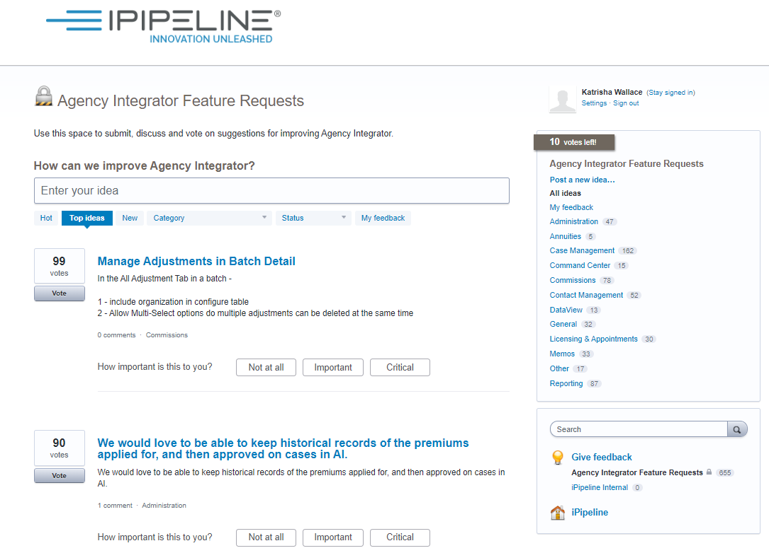

Submitting New Enhancement Requests
To submit a new idea for improving Agency Integrator, type in the box labeled Enter your idea: 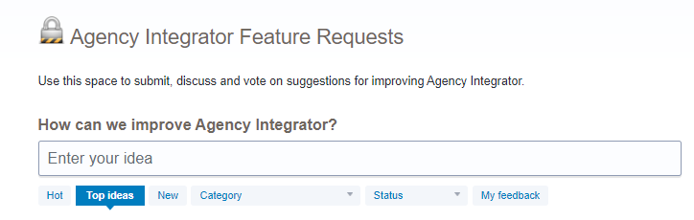
As you do so, a search of the current list of Enhancement Requests will be performed automatically to help you determine if your idea has already been submitted: 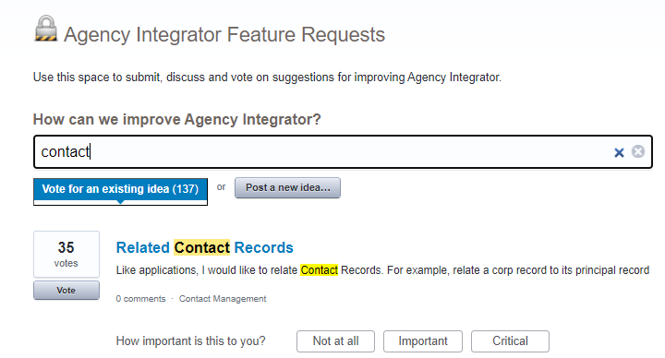
If the search returns a similar idea that has already been submitted, you may want to vote on it, and/or participate in the discussion surrounding it.
If your idea hasn’t already been submitted, you can do so by completing the fields shown and clicking the Post a new idea button:
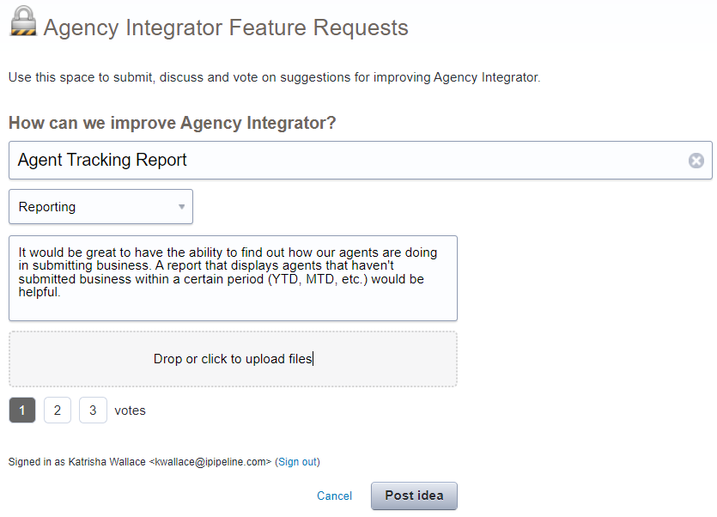
Keep in mind that the text you enter in the Enter your idea field will become the title of your new idea that others will view and search for. Make sure it’s descriptive, specific, and representative of your idea. You may also decide to allocate some of your Votes on this new idea as well. Voting will be described later in this TechNote.

Reviewing Enhancement Requests
UserVoice allows you to review existing Enhancement Requests right on the main page. By default, the list of enhancements you see are those with the highest number of votes.

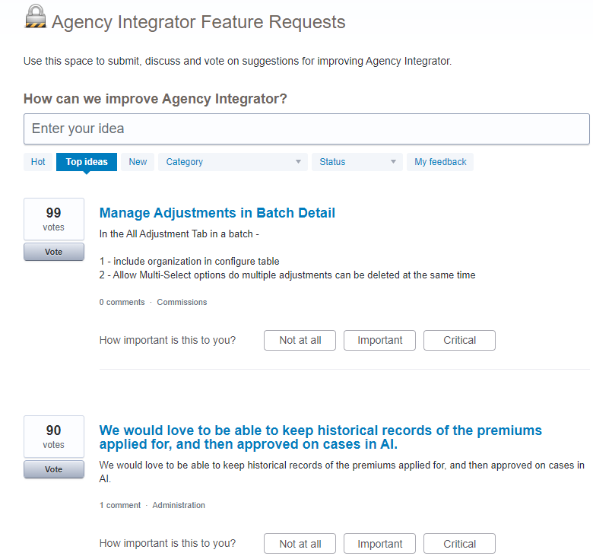
However, you can also choose to view the list of enhancements by the following:
- Hot ideas: The Enhancement Requests with a lot of activity in a short period of time
- Top Ideas: The Enhancement Requests with the highest number of votes
- New: The most recently submitted Enhancement Requests
- Category: Lists of Enhancement Requests based on their categorization, such as Reporting, Case Management or Administration
- Status: List of Enhancement Requests based on their status, such as Under Review, Started or Completed
- My Feedback: List of ideas that your user ID has supported or commented on.
If you would like to see more information about a specific Enhancement Request, simply click on the title of the idea and the full detail will be displayed, along with any comments submitted by iPipeline staff, our User Group Advisory Board members, and other Agency Integrator users.
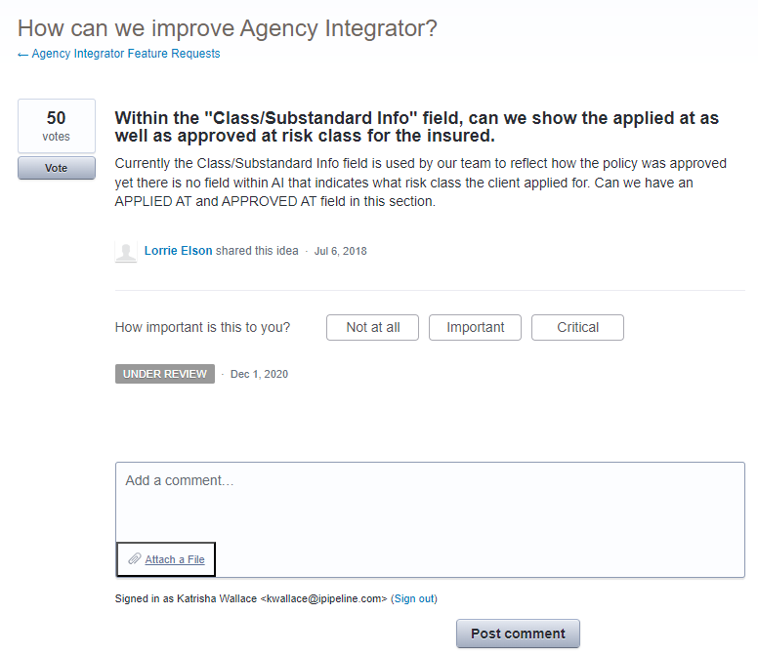

Discussing Enhancement Requests
Perhaps you have a question as to how a particular enhancement could be implemented or incorporated to be of the most use to your agency. Perhaps your agency has already discovered a process that makes the enhancement less impactful. Or, perhaps you really like the enhancement and want to show your support with more than just a vote.
UserVoice allows for an active discussion on each item by allowing users to post Comments for each idea.
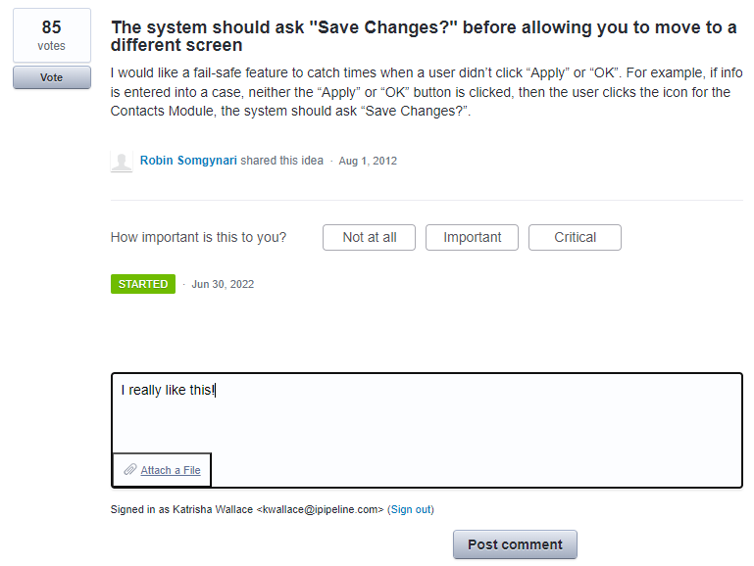

Voting on Enhancement Requests
Each user has a total of 10 votes to use. The number of votes you have left will appear to the right of the Enter your idea field:

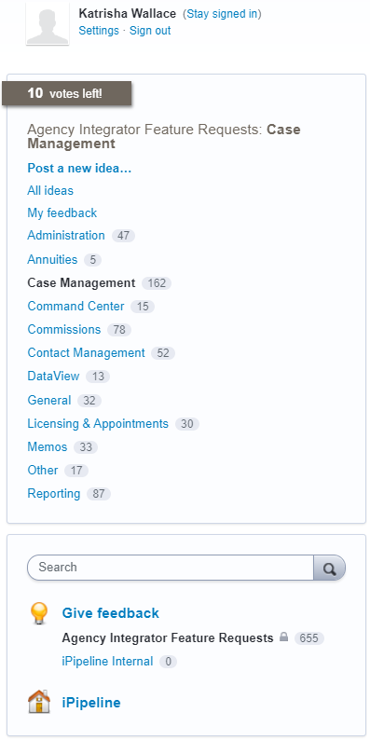

This notation will also update each time you use votes to indicate how many you have remaining.

Voting on Enhancement Requests is simple. Click on the Vote button to log your vote.
You also have the option to vote multiple times on a single idea. You’re allowed to allocate up to three votes on an Enhancement Requests.
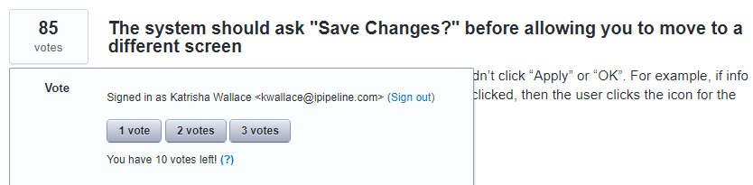
Once you’ve used up all 10 of your votes, you may not vote for any more enhancements. However, there are two ways to get your votes back:
- You can remove your votes from any previously voted on enhancements by clicking on the Remove Votes button.
- Once an Enhancement Request is closed (e.g., completed), any votes allocated to that Enhancement are returned to those who voted on it.

UserVoice Settings
In addition to the main features of UserVoice, there are some optional components that you may wish to take advantage of. Click on Settings under your name in the upper right of the page to view a list of these optional settings:
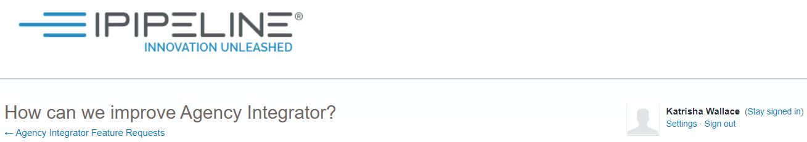
Within this Settings area, you can add an Avatar (such as a picture of yourself) and choose how you are notified by UserVoice when updates are made to your ideas.

